**CROI Doxycycline PEP/PrEP Abstracts**

1. **Doxycycline Postexposure Prophylaxis for Prevention of STIs Among Cisgender Women**

Jenell Stewart, Kevin Oware, Deborah Donnell, Lauren R.Violette, Josephine Odoyo, Caitlin W.Scoville, Olusegun O.Soge, Victor Omollo, Felix Mogaka, Fredricka A.Sesay, R. Scott McClelland, Elizabeth A.Bukusi, Jared M.Baeten

**Background:**

Bacterial sexually transmitted infections (STIs) are repsonsible for significant and disproportionate morbidity and mortality in cisgender women, among whom STI incidence has been rising globally. Doxycycline taken as postexposure prophylaxis (PEP) was efficacious at preventing STIs among cisgender men who have sex with men and transgender women, but no trials among cisgender women have been done.

**Methods:**

We conducted an open-label randomized trial of doxycycline PEP (doxycycline hyclate 200mg taken within 72 hours of sex) compared with standard of care (e.g., quarterly screening and treating STIs) among women aged 18-30 years in Kisumu, Kenya. Participants were required to already be taking daily oral HIV preexposure prophylaxis (PrEP). Contraception was not required, and doxycycline was stopped during pregnancy. Weekly SMS surveys were done to assess concomitant doxycycline PEP use with sex. The primary endpoint was any incident Chlamydia trachomatis, Neisseria gonorrhoeae, or Treponema pallidum infection, measured quarterly for one year; the trial had 80% power to detect 50% reduction in incident STIs, anticipating 66 incident STIs.

**Results:**

We enrolled 449 cisgender women; women completed 97% of expected follow-up visits. Median age was 24 years (IQR 21-27), 36.7% reported transactional sex at enrollment, and baseline STI prevalence was 17.9% (14.1% C. trachomatis, 3.8% N. gonorrhoeae, 0.4% T. pallidum). Incident STI events were detected at 109 follow up visits (85 C. trachomatis, 31 N. gonorrhoeae, including 8 with both; 1 T. pallidum): 50 among those assigned to doxycycline PEP and 59 among those assigned STI screening and treatment alone (RR 0.88, 95% CI 0.60-1.29, p=0.51). Analysis with follow-up time censored once participants became pregnant (n=80), analysis of each STI separately, and subgroup analyses (including by age, contraceptive use, transactional sex, and STI detected at baseline) found similar results. There were no serious adverse events determined to be related to use of doxycycline. No incident HIV infections were detected. Weekly SMS surveys had an overall 81% response rate, and women assigned to PEP reported taking doxycycline PEP at least as many days they had sex in 78% of surveys.

**Conclusions:**

Among young cisgender women with high prevalence and incidence of STIs, the use of doxycycline PEP following sex did not reduce incident STIs.

[**Doxycycline Postexposure Prophylaxis for Prevention of STIs Among Cisgender Women**](https://www.croiwebcasts.org/p/2023croi/croi/121)

1. **Mucosal Pharmacology of Doxycycline for Bacterial STI Prevention in Men and Women**

Richard Haaland, Jeffrey Fountain, Chuong Dinh, Tiancheng Edwards, Amy Martin, Deborah Omoyege, Christopher Conway-Washington, Colleen Kelley, Walid Heneine

**Background:**

Oral doxycycline (DOX) prophylaxis is a promising strategy to prevent bacterial sexually transmitted infections (STIs). Clinical trials demonstrated a 200 mg oral DOX dose taken by men who have sex with men (MSM) after sexual exposure can provide protection against STIs. However, mucosal pharmacokinetic data at the site of STI exposure and DOX activity are lacking. We examined mucosal DOX concentrations in men and women to better understand DOX efficacy and inform dose optimization for STI prevention.

**Methods:**

Eleven male and 9 female participants provided blood and mucosal swabs up to 7 days after receiving a 200 mg oral DOX dose. Rectal, vaginal and cervical biopsies as well as urethral swabs were collected 24 hours after dosing. DOX was measured by liquid chromatography-mass spectrometry with a lower limit of quantification of 10 ng/mL for plasma and 2.5 ng/sample for swabs and biopsies. Secretion concentrations were estimated using swab weight. Concentrations are reported as geometric mean and 95% confidence interval. Time above the 90% minimum inhibitory concentration (MIC90) was assessed for susceptible Neisseria gonorrhoeae (NG), Treponema pallidum (TP) and Chlamydia trachomatis (CT).

**Results:**

Rectal secretion DOX concentrations peaked at 48 hours, 8 hours in vaginal secretions, and 4 hours in plasma. Rectal and vaginal DOX exposure up to 96 hours were 2- and 3-times that of plasma, respectively. Rectal and vaginal secretion DOX concentrations remained above the MIC90 for 48, 72 and 96 hours, longer than in plasma, for NG, TP and CT, respectively. DOX concentrations in rectal (616 ng/g; 495 – 766 ng/g), vaginal (261 ng/g; 98 – 696 ng/g) and cervical tissue (410 ng/g; 193 – 870 ng/g) were only 1- to 2-times the MIC90 for NG, but at least 2- and 4-times greater than the MIC90 for TP and CT, respectively. Urethral secretion DOX was estimated to be at least 4-times the MIC90 for NG, TP and CT, and greater than plasma or mucosal concentrations.

**Conclusions:**

DOX efficiently distributes to mucosal sites and maintains inhibitory concentrations against TP and CT for 3-4 days after dosing, but only 2 days for NG which may impact level of protection. This study provides the first pharmacologic data on mucosal DOX exposures associated with STI protection among MSM, predicts high vaginal efficacy, and informs a rational DOX dose optimization for STI prevention in men and women.

**Mucosal Pharmacology of Doxycycline for Bacterial STI Prevention in Men and Women**

1. **Daily Doxycycline in MSM on PrEP for Prevention of Sexually Transmitted Infections**

Troy Grennan1, Mark Hull2, Saira Mohammed2, Tessa Tattersall1, Joshua Edward1, Amit Gupta1, Michelle K. Dennehy3, Marc Romney4, Muhammad Morshed1, Wendy Zhang2, Sidhant Guliani2, Jason Trigg2, Viviane D. Lima2, Julio S. Montaner2, Reka Gustafson1

MSM continue to experience high rates of sexually transmitted infections (STI). Use of HIV pre-exposure prophylaxis (PrEP) significantly reduces risk of HIV infection, and a similar strategy using daily doxycycline may serve as STI PrEP. We undertook a pilot study to determine STI outcomes of HIV-negative MSM on dual HIV/STI PrEP.

HIV-negative MSM with prior diagnosis of syphilis received 48 weeks of tenofovir DF 300mg-emtricitabine 200mg daily and were randomized 1:1 to receive either immediate daily doxycycline 100mg, or deferred doxycycline beginning 24 weeks later in an open-label pilot study of Dual Daily HIV and Syphilis PrEP (The DuDHS Study) in Vancouver, Canada. Participants underwent screening for STI every 3 months, with Staphylococcus aureus nares cultures collected to evaluate tetracycline/doxycycline resistance by Kirby Bauer testing. STI rates were compared between those on dual PrEP vs. HIV PrEP alone over the initial 24 weeks using Fishers Exact test.

Fifty-two MSM were randomized with median age of 34 years (interquartile range [IQR], 29 – 43). Overall, 55.8% self-reported prior gonorrhea and chlamydia infection. Chlamydia infection occurred only in the deferred arm during the first 24 weeks (n=10) (rate 0 vs. 81.63/100 PY, p = 0.001), subsequently no infections occurred in either arm. No individuals in the immediate arm, and one individual in the deferred arm developed syphilis infection during the first 24 weeks (rate 0 vs. 8.16/100 PY, p = 0.98) with no infections seen thereafter in either arm. By 24 weeks, n= 4 in the immediate arm and n=7 in the deferred arm tested positive for gonorrhea (rate 31.37 vs. 57.14/100 PY, p= 0.505), and only one additional infection was seen in each arm for 24 – 48 weeks. In a logistic model receipt of doxycycline was associated with reduced probability of any STI (OR 0.18, 95% CI 0.05 – 0.68) during the first 24 weeks. Tetracycline resistance was seen in 1/3 S. aureus isolates at 24 weeks and 3/6 isolates at 48 weeks in the immediate arm and in 1/2 isolates after six months of doxycycline use in the deferred arm.

STI PrEP using daily doxycycline demonstrated decreased rates of chlamydia infection while impact on syphilis could not be ascertained. Tetracycline resistance amongst nasal carriage of S.aureus was observed over the study duration. Further evaluation of potential benefits and antimicrobial resistance in a larger study may be warranted.

[**Daily Doxycycline in MSM on PrEP for Prevention of STIs the DuDHS Study**](https://www.croiwebcasts.org/console/player/47786?mediaType=slideVideo&)

1. **DOXYPEP & Antimicrobial Resistance in N. Gonorrhoeae, Commensal Neisseria & S. Aureus**

Anne F.Luetkemeyer, Deborah Donnell, Julia C.Dombrowski, Stephanie Cohen, Cole Grabow, Clare Brown, Cheryl Malinksi, Sharon K.Martens, Alison Cohee, Veronica Viar, Phong Pham, Susan P.Buchbinder, Diane V.Havlir, Connie L.Celum, Olusegun O.Soge

**Background:**

Doxycycline post-exposure prophylaxis (doxy-PEP) is highly effective in reducing N. gonorrhoeae (GC), C. trachomatis (CT), and syphilis among men who have sex with men (MSM) and transgender women (TGW). Understanding the effect of doxy-PEP use on antimicrobial resistance (AMR) in N.gonorrhoeae and bacteria which can cause disease (S.aureus) or transmit resistance (Neisseria spp) is unknown.

**Methods:**

DoxyPEP is a randomized open-label trial among MSM/TGW living with HIV or on PrEP with GC, CT, or early syphilis in the past year; participants were randomized 2:1 to 200 mg doxycycline within 72 hours of condomless sex or no doxycycline (SOC). At months 0 (M0) and 12 (M12), nasal/oropharyngeal swabs were cultured for S. aureus (SA) with doxycycline resistance (doxy-R) defined as MIC ≥16 µg/ml by E-test and oropharyngeal swabs cultured for commensal Neisseria (doxy-R: MIC ≥2 µg/ml by E-test). Participants with a positive GC test were instructed to return for swabs for GC culture through the CDC SURRG program (TCN-R: MIC≥2.0 µg/ml by agar dilution). Overall proportion with growth or AMR at M12 were compared by Fisher’s exact test.

**Results:**

Of 501 participants as of May 2022, S.aureus was cultured at M0 in 44.2% and doxy-R SA in 6.3% (Table). At M12, S.aureus was cultured from 29.2% in the doxy-PEP arm and 45.2% in the SOC arm (p=0.036), with doxy-R SA present in 11.7% and 4.8% (p= 0.19), respectively. At M0, methicillin-resistant-SA (MRSA) was cultured from 5.9%, and at M12, 1.5% in the doxy-PEP arm and 6.5% in SOC arm (p=0.077). At M0, Neisseria spp were cultured from 86.8% with doxy-R Neisseria in 61.8%. At M12, Neisseria spp were cultured from 85.2% in the doxy-PEP arm and 89.3% in the SOC arm (p = 0.64), and doxy-R was 69.7% and 44.6%, respectively (p=0.017). Among GC diagnoses, 17% (44/256) had phenotypic susceptibility results; M0 TCN-R was 28.4% (4/15), and after enrollment, 38.5% (5/13) in the doxy-PEP arm and 12.5% (2/16) in the SOC arm.

**Conclusions:**

Doxy-PEP reduced S.aureus colonization by 16% without a significant increase in doxy-R SA. A majority had doxy-R commensal Neisseria at baseline, with an unexpected decrease in doxy-R Neisseria spp in the SOC arm. These modest changes in doxy-R S.aureus and Neisseria spp are unlikely to have clinical significance and must be considered in context of >60% STI reduction with doxy-PEP. Doxy-PEP may be less protective against incident TCN-R GC; surveillance for the impact of TCN-R GC on doxy-PEP efficacy and doxy-PEP on GC resistance is needed.

S.aureus, Neisseria spp, and N. gonorrhoeae: Bacterial isolation and phenotypic resistance to the tetracycline antibiotic class at enrollment and during DoxyPEP study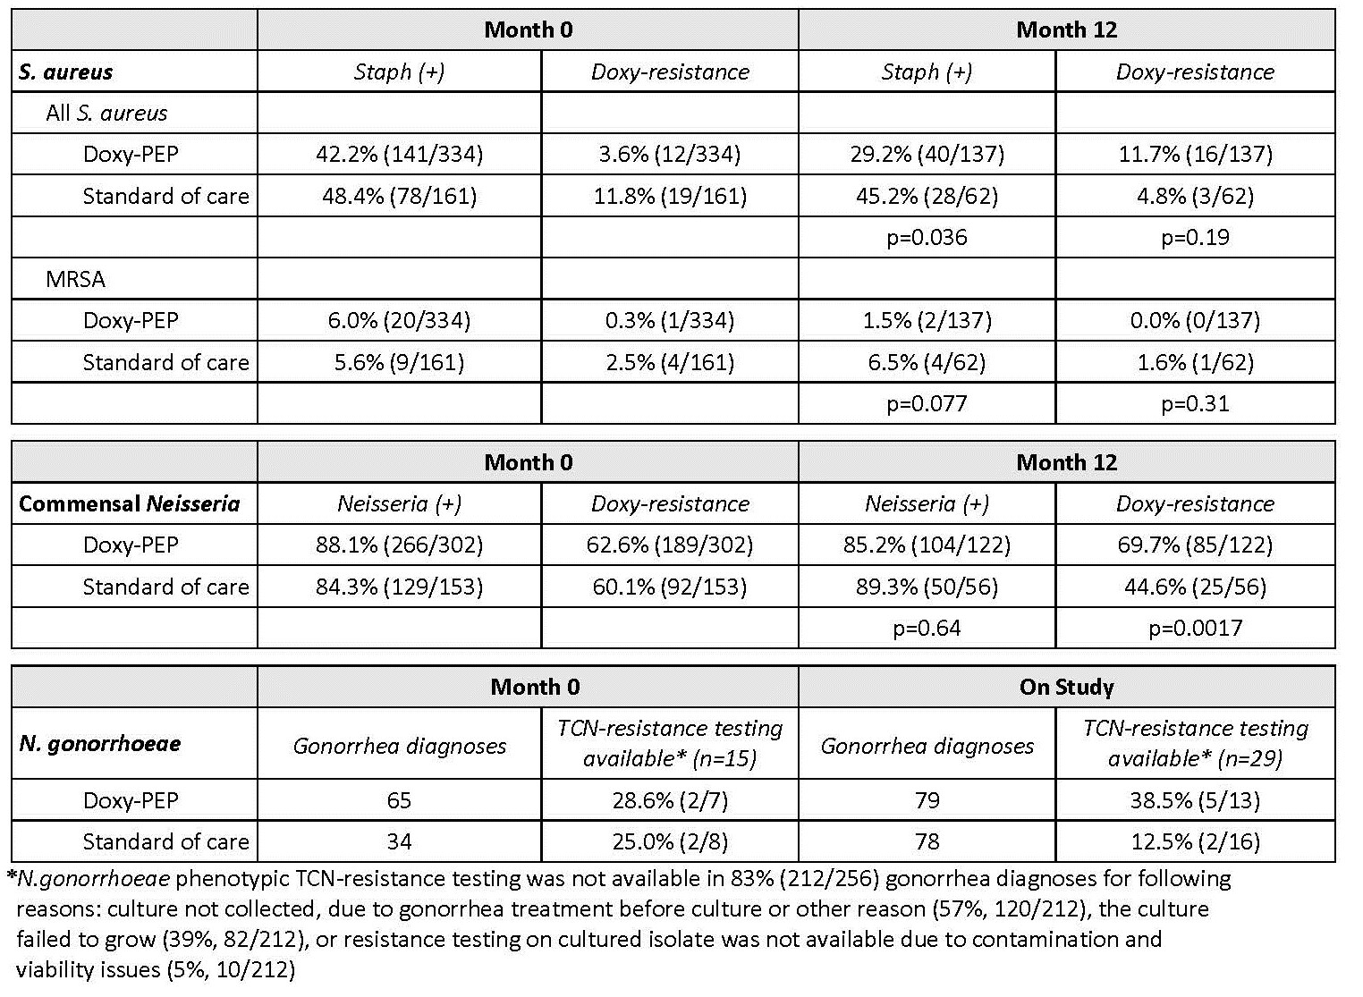

[**DOXYPEP & Antimicrobial Resistance in N. Gonorrhoeae, Commensal Neisseria & S. Aureus**](https://www.croiwebcasts.org/console/player/51577?mediaType=slideVideo&)

1. **Potential Impact and Efficiency of DOXY-PEP Among People with or at risk of HIV**

Michael W.Traeger, Kenneth H.Mayer, Douglas S.Krakower, Sy Gitin, Samuel Jenness, Julia L.Marcus

**Background:**

Doxycycline post-exposure prophylaxis (doxy-PEP) reduces bacterial sexually transmitted infection (STI) risk in people with HIV (PWH) or using HIV preexposure prophylaxis (PrEP). However, ongoing decision-making about federal and local guidance for doxy-PEP prescribing is complicated by concerns about potential harms of widespread use. We sought to identify doxy-PEP prescribing strategies that would minimize overall doxy-PEP use while maximizing impact on STIs.

**Methods:**

We used electronic health record data on gay and bisexual men (GBM), transgender women, and non-binary people assigned male at birth with ≥2 STI tests (chlamydia, gonorrhea, or syphilis) at Fenway Health, a Boston clinic focused on LGBT health, during 2015-2020. Patients were followed from first STI test until last test or end of 2020. We defined 10 potential doxy-PEP prescribing strategies: prescribed to (1) all individuals, (2) PrEP users, (3) PrEP users/PWH; and prescribed after (4) any STI, (5) rectal STI, (6) ≥2 STIs in 12m, (7) ≥2 STIs in 6m, (8) ≥2 concurrent STIs, (9) syphilis or (10) gonorrhea Dx. We also explored strategies 4–10 restricted to PrEP users/PWH. We evaluated counterfactual scenarios in which patients who met each criterion were prescribed doxy-PEP indefinitely (strategies 1–3) or for 12m (strategies 4–10). We assumed STI incidence during doxy-PEP use would have been reduced by clinical trial efficacy estimates. For each strategy, we estimated the proportion prescribed doxy-PEP, overall STIs averted, and number needed to treat with doxy-PEP per year to avert 1 STI (NNT).

**Results:**

Among 10,562 patients (94% GBM; 54% PrEP users; 14% PWH), incidence of any STI was 39.8/100py. Across strategies, NNT ranged from 1.0–3.8 (median=1.7) and proportion of STIs averted ranged from 8%–70% (median=20%). Prescribing doxy-PEP to all patients averted 70% of STIs (NNT=3.7); prescribing to PrEP users/PWH (68% of patients) averted 60% of STIs (NNT=2.9; Figure). Prescribing doxy-PEP after any STI reduced the proportion of patients on doxy-PEP to 41% and averted 42% of STIs (NNT=2.9). Prescribing after concurrent or repeated STIs was most efficient (lowest NNTs). Restricting strategies 4–10 to PrEP users/PWH had minimal effect on NNT and reduced impact on STIs.

**Conclusions:**

Prescribing doxy-PEP to individuals with STIs, particularly concurrent or repeated STIs, could avert a substantial proportion of subsequent STIs. The most efficient prescribing strategies are based on STI history rather than HIV status or PrEP use.

Proportion of individuals prescribed doxy-PEP (red), proportion of STIs averted (blue), and number needed to treat (NNT) with doxy-PEP for one year to avert one STI (right) for each doxy-PEP prescribing strategy. 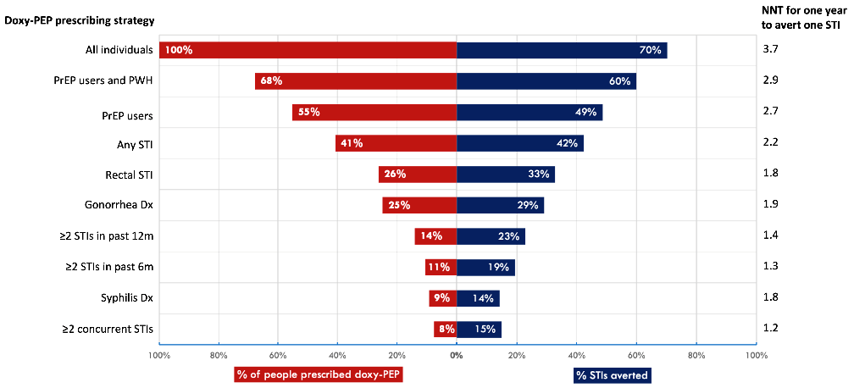

[**Potential Impact and Efficiency of DOXY-PEP Among People with or at risk of HIV**](https://www.croiwebcasts.org/console/player/51583?mediaType=slideVideo&)

1. **ANRS 174 DOXYVAC: An Open-Label Randomixed Trial to Prevent STIs in MSM on PrEP**

Jean-Michel Molina, Beatrice Bercot, Lambert Assoumou, Algarte-Genin Michele, Emma Rubenstein, Gilles Pialoux, Christine Katlama, Laure Surgers, Cecile Bebear, Nicolas Dupin, Jean-Paul Viard, Juliette Pavie, Claudine Duvivier, Jade Ghosn, Dominique Costagliola

**Background:**

Increased rates of sexually transmitted infections (STI) are reported among men who have sex with men (MSM), in particular those using pre-exposure prophylaxis for HIV (PrEP). Interventions to reduce STI incidence are needed.

**Methods:**

MSM on PrEP with a history of STI in the past year, were randomized in an open-label factorial design trial to receive doxycycline post-exposure prophylaxis (Doxy PEP: 200 mg within 72h of condomless sex) or no PEP (2:1); and 2 shots of meningococcal B vaccine (Bexsero°) or no vaccine (1:1). Participants were tested centrally at baseline, every 3 months and when symptomatic for N. gonorrhoeae (GC) and C. trachomatis (CT) by PCR in throat, anus and urine. Serologic tests for syphilis were performed every 3 months. A committee adjudicated STI blinded to study arms. The co-primary endpoints were: the incidence of first episode of CT or syphilis for Doxy PEP and the incidence of a first episode of GC, 1 month after the second injection, for the vaccine intervention, using an intent-to-treat analysis. We used Cox proportional hazard models to compare incidence between Doxy PEP and no PEP adjusted for vaccine intervention and vice versa. Following external evidence, a single interim analysis occurred in September 2022 at the request of the DSMB who recommended to stop the trial for efficacy. Results for data collected up to July 15, 2022 are presented.

**Results:**

Between January 19, 2021, and July 15, 2022, 546 MSM were randomized and 502 were analyzed. Median age: 39 years, median of 10 sexual partners in past 3 months. Median follow-up: 9 months. There was no interaction between the two prevention strategies for the primary endpoints. The incidence of a first episode of CT or syphilis was 5.6 and 35.4 per 100 PY in the Doxy PEP and no PEP arms, respectively (aHR: 0.16; 95%CI: 0.08-0.30). The incidence of a first episode of GC was 20.5 and 41.3 per 100 PY in the Doxy PEP and no PEP arms, respectively (aHR: 0.49; 95%CI: 0.32-0.76). The incidence of a first episode of GC was 9.8 and 19.7 per 100 PY in the meningococcal B vaccine and no vaccine arms, respectively (aHR: 0.49; 95%CI: 0.27-0.88). No drug-related SAE was reported.

**Conclusions:**

Among MSM on HIV PrEP, doxycycline PEP significantly reduced the incidence of CT and syphilis and also had a significant impact on the incidence of GC. Meningococcal B vaccine also reduced the incidence of GC.

[**ANRS 174 DOXYVAC: An Open Label Randomized Trial to Prevent STIs in MSM on PrEP**](https://www.croiwebcasts.org/console/player/51576?mediaType=slideVideo&)

1. **On Demand Post Exposure Prophylaxis with Doxycycline for MSM Enrolled in a PrEP Trial**

Jean-Michel Molina1, Isabelle Charreau2, Christian Chidiac3, Gilles Pialoux4, Eric Cua5, Constance Delaugerre1, Catherine Capitant2, Daniela Rojas-Castro6, Laurence Meyer7

A high incidence of bacterial sexually transmitted infections (STIs) has been reported in several PrEP trials and demonstration projects among MSM. We wished to assess whether on demand post-exposure prophylaxis (PEP) with doxycycline could reduce STIs incidence in this high risk group.

High risk adult MSM being followed in the open-label phase of the ANRS IPERGAY trial with on demand TDF/FTC for HIV prevention, were enrolled in a prospective randomized open-label sub-study. Participants (pts) were randomized 1:1 to take either two pills of doxycycline (100mg per pill) within 72h after condomless sexual intercourse (without exceeding 6 pills per week) or no PEP. All subjects received risk-reduction counseling and condoms, and were tested every 8 weeks for HIV and STIs with serologic assays for HIV and syphilis and PCR assays for Chlamydia trachomatis and Neisseria gonorrhoeae in urine samples, oral and anal swabs. The primary study endpoint was the time to a first bacterial STI: gonorrhoea, chlamydia infection or syphilis. We compared the two study arms according to the intention-to-treat principle. We used time-to-event methods, including Kaplan–Meier survival curves and Cox proportional-hazards models.

From July 2015 to January 2016, 232 pts were randomized, 116 in each arm. Median follow-up was 8.7 months (IQR: 7.8-9.7). Seventy-three pts acquired STIs during the study period, 28 pts in the PEP arm (24%, 37.7 events per 100 pt-years) as compared to 45 pts in the no PEP arm (38.8%, 69.7 events per 100 pt-years) for a hazard ratio (HR) of 0.53 (95% CI: 0.33-0.85, P=0.008). HR for gonorrhoea, chlamydia infection and syphilis were 0.83 (95% CI: 0.47-1.47, p=0.52), 0.30 (95% CI: 0.13-0.70, p=0.006) and 0.27 (95% CI: 0.07-0.98, p<0.05), respectively. Overall 71% of all STIs were asymptomatic. Pts in the PEP arm used a median of 7 pills/month (IQR: 3-13). Safety was good with only 8 pts (7%) discontinuing PEP because of gastro-intestinal adverse events (AEs). Gastrointestinal AEs were reported in 61 pts (53%) and 47 pts (41%) in the PEP and no PEP arms, respectively (p=0.07). There was no significant change in sexual behavior between study arms during follow-up.

On demand PEP with doxycycline reduced the incidence of chlamydia infection and syphilis in high risk MSM and has an acceptable safety profile. The long-term efficacy of this strategy and its impact on antibiotic resistance needs to be assessed.

**NO VIDEO PRESENTATION AVAILABLE**